

# 

# About GCA

The Geospatial Council of Australia is the peak body representing the interests of organisations and professionals, including new and emerging professionals working in the vast range of occupations for surveying, space and spatial in the digital world.

ESP-AP Application Form Version 1.2 © Geospatial Council of Australia Ltd. 2023

Table of Contents

About GCA 2

Introduction 4

Submission & Queries 4

Acknowledgement & Code of Ethics 4

Eligibility Criteria 5

Personal Details 6

Application Type 6

Educational Achievement 6

Course Points 7

Educational Achievements Summary Table 8

Professional Work Experience 8

Professional Work Experience Summary Table 9

Application Points Summary 10

Payment 11

Application Checklist 12

# Introduction

This document is the application form you complete to be considered for certification as an **Engineering Surveying Professional – Asia Pacific (ESP-AP)**. We commend you for taking this voluntary step forward in your professional development.

The ESP-AP Certification Application must be submitted with **proper supporting documentation**, which is detailed in the comprehensive Certification Manual. This manual should be consulted often as you fill out the application below. The tips and strategies will help to make the application process simpler for you and the ESP-AP Certification Panel. It is important that you complete all parts of the applications and follow the guidelines and checklists noted in the Manual to avoid delay of the review of your application.

# Submission & Queries

Please return the completed application form and all supporting documentation as a PDF to the Geospatial Council Coordinator via email:- [certification@geospatialcouncil.org.au](mailto:certification@geospatialcouncil.org.au)

If you have any questions about ESP-AP certification, please refer to the Certification Manual in the first instance. For further queries, please contact the Geospatial Council Program Lead using the above email address or telephone +61 2 6159 8220.

# Acknowledgement & Code of Ethics

I acknowledge the information provided in the application is a true and accurate record of my achievements and experience.

I acknowledge I have fully read, understand and in compliance with the Geospatial Council of Australia’s (GCA) [Code of Ethics](https://geospatialcouncil.org.au/governance/). I understand and agree that upon receipt of proof of violation of this Code, the GCA Board will undertake investigation and further action may be taken.

|  |  |  |
| --- | --- | --- |
| **Signature:** |  | **Date:** Click or tap here to enter text. |

# Eligibility Criteria

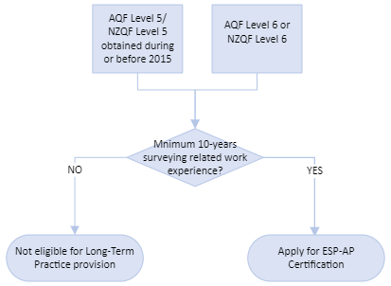

Long-Term Practice Provision

Qualification Provision

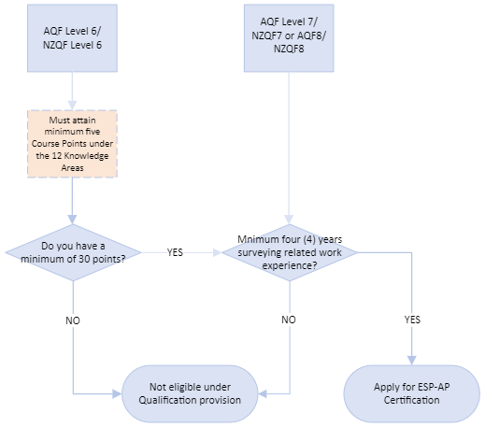

# Personal Details

|  |  |  |
| --- | --- | --- |
| **Full Name:** |  | Click or tap here to enter text. |
| **Position:** |  | Click or tap here to enter text. |
| **Organisation:** |  | Click or tap here to enter text. |
| **Postal Address:** |  | Click or tap here to enter text. |
| **Email:** |  | Click or tap here to enter text. |
| **Telephone:** |  | Click or tap here to enter text. |
| **GCA Membership No.:** |  | Click or tap here to enter text. |

# Application Type

I would like to be considered under the **Long-Term Practice Provision.**

I would like to be considered under the **Qualification Based Provision.**

# Educational Achievement

**Long-Term Practice Provision Qualification Based Provision**

* This section is MANDATORY
* The **minimum points required is 30**
* If you have an AQF/NZQF Level 6, you must acquire additional Course Points
* Update Educational Achievement table
* Course Points are NOT REQUIRED
* Then proceed to the Work Experience section.

To apply under the Qualification provision, update the Educational Achievement table and assign the relevant point(s) based on the credential you have attained.

If your highest qualification is an AQF/NZQF Level 6, you will not meet the minimum 30 points requirement. You must therefore obtain additional educational qualifications to gain the extra points by way of further studies in one or more of the 12 Knowledge Areas of Engineering Surveying. In the Course Points table, assign one point per Certificate.

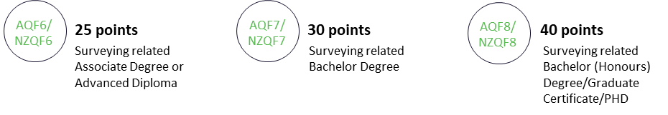

|  |  |  |  |
| --- | --- | --- | --- |
| **Educational Achievement** | | | |
| **Highest Surveying-Specific Credential** | **Institution** | **Year**  **Conferred** | **Points** |
| Click or tap here to enter text. | Click or tap here to enter text. | Click or tap here to enter text. | Click or tap here to enter text. |
| Click or tap here to enter text. | Click or tap here to enter text. | Click or tap here to enter text. | Click or tap here to enter text. |
| **TOTAL EDUCATIONAL ACHIEVEMENTS POINTS** | | | **0.00** |

# Course Points

Under the Qualification provision if you have an AQF/NZQF Level 6 and need to provide a minimum of five additional education points related to the 12 Knowledge Areas, update this table:-

|  |  |  |  |  |
| --- | --- | --- | --- | --- |
| **Surveying-Specific Credential** | **Knowledge Area** | **Institution/Course Provider** | **Certificate**  **Date** | **Points** |
| Click or tap here to enter text. | Click or tap here to enter text. | Click or tap here to enter text. | Click or tap to enter a date. | Click or tap here to enter text. |
| Click or tap here to enter text. | Click or tap here to enter text. | Click or tap here to enter text. | Click or tap to enter a date. | Click or tap here to enter text. |
| Click or tap here to enter text. | Click or tap here to enter text. | Click or tap here to enter text. | Click or tap to enter a date. | Click or tap here to enter text. |
| Click or tap here to enter text. | Click or tap here to enter text. | Click or tap here to enter text. | Click or tap to enter a date. | Click or tap here to enter text. |
| Click or tap here to enter text. | Click or tap here to enter text. | Click or tap here to enter text. | Click or tap to enter a date. | Click or tap here to enter text. |
| **TOTAL EDUCATIONAL COURSE POINTS** | | | | **0** |

# 

# Educational Achievements Summary Table

You must add all the Educational Achievement and where relevant, Course Points into the Summary table below, to give the total number of education points earned (subject to approval by the ESP-AP Panel).

The total education points must be **at least** 30, with a maximum of 40 points.

|  |  |
| --- | --- |
| **Category** | **Points** |
| **Educational Achievement** | Click or tap here to enter text. |
| **Course Points (if relevant)** | Click or tap here to enter text. |
| **TOTAL EDUCATION POINTS** | **0** |

# Professional Work Experience

Complete this section for both Long-Term Practice and the Qualifications based provisions.

Use the work experience template and examples from the Candidate Guide to capture your surveying-related work experience. It is imperative that you refer to the Competency Framework when completing this section. Remember to copy and paste your completed Work Experience template forms in the next section titled, Work Experience Worksheets.

Once you have added your Worksheets, take the sub-total from each work experience example you have added to your application form and add that figure to the Professional Work Experience Summary table in the following section.

Formula for calculating Work Experience Points is:- **Duration in Months/12 x Points Per Year**

**Qualification Based**

* 4-years surveying-related work experience
* Min. **110** work experience points out of 150 points

**Long-Term Practice Provision**

* 10-years surveying related work experience
* Min. 300 work experience points

# Work Experience Worksheets

**\*duplicate this blank template for each example\***

**\*paste all completed worksheets numbered consecutively in this section\***

|  |  |  |
| --- | --- | --- |
| **Work Experience Example Number:** Click or tap here to enter text.  **Employer/Supervisor/Client Referee Name:** Click or tap here to enter text. | | |
| **Project Description:** Click or tap here to enter text. | | |
| **Category:** Click or tap here to enter text. | | **Sub-category:** Click or tap here to enter text. |
| **Responsibilities:** Click or tap here to enter text. | | |
| **Performance Criteria:** Click or tap here to enter text. | | |
| **Supporting Evidence:** Click or tap here to enter text. | | |
| **Duration**  **(MM/YY to MM/YY):** Click or tap here to enter text.  **Months:**  Click or tap here to enter text. | **Points Per Year:**  Click or tap here to enter text. | **POINTS SUB-TOTAL:**  Click or tap here to enter text. |

# Professional Work Experience Summary Table

|  |  |  |  |  |
| --- | --- | --- | --- | --- |
| **Worksheet No.** | **Category** | **Duration (months)** | **Points Per Year** | **Points** |
|  | Survey control network (Primary) |  | 30 |  |
|  | Survey control network (Medium) |  | 25 |  |
|  | Survey control network (Simple) |  | 20 |  |
|  | Bridge (Large/Complex) |  | 35 |  |
|  | Bridge (Medium/Complex) |  | 30 |  |
|  | Bridge (Simple) |  | 25 |  |
|  | Road (major motorways) |  | 35 |  |
|  | Road (major arterial) |  | 30 |  |
|  | Road (minor arterial) |  | 25 |  |
|  | Road (low volume rural / urban) |  | 20 |  |
|  | Earthworks (Substantial) |  | 25 |  |
|  | Earthworks (Minor) |  | 15 |  |
|  | Drainage (Complex) |  | 30 |  |
|  | Drainage (Simple) |  | 20 |  |
|  | Water/wastewater network (Large/Complex) |  | 25 |  |
|  | Water/wastewater network (Minor/Simple) |  | 20 |  |
|  | Retaining structures (Substantial & Complex) |  | 30 |  |
|  | Retaining structures (Simple) |  | 20 |  |
|  | Topographical (Complex) |  | 25 |  |
|  | Topographical (Simple) |  | 20 |  |
|  | Management |  | 10 one-off |  |
|  | Cadastral Surveying |  | 25 one-off |  |
|  | Other |  | TBC |  |
| **TOTAL DURATION** | | **0** | **TOTAL POINTS** | **0** |

# Application Points Summary

|  |  |
| --- | --- |
| **Category** | **Combined Points** |
| **Educational Achievement & Course Points (if relevant)** | Click or tap here to enter text. |
| **Professional Work Experience** | Click or tap here to enter text. |
| **TOTAL APPLICATION POINTS** | **0** |

* + **Minimum 300 points** for applicants under the **Long-Term Practice Provision**
  + **Minimum 150 points** for applicants under the **Qualification Based Provision**.

# Payment

**Certification Fee**

New Application or Certifications lapsed 3+ years for Geospatial Council Member $330.00

New Application or Certifications lapsed 3+ years for Non-member $850.00

Re-Certifications (lapsed <3 years) for Geospatial Council Member $220

Re-Certifications (lapsed <3 years) for Non-member $605

The fee must be received in full before an application will be considered.

**Payment Methods**

Our preferred payment method is online directly via our [Certification page](https://geospatialcouncil.org.au/esp-ap-certification/) or our online [Shop](https://geospatialcouncil.org.au/shop/).

Select the relevant fee from the list and proceed through the payment steps.

Alternatively, you may make an Electronic Fund Transfer (EFT). The necessary bank information is provided below: -

*Bank:* Commonwealth Bank of Australia

*Account Name:* Geospatial Council of Australia

*BSB:* 064-000

*Account No:* 15974652

*Reference:* ESP-AP <Applicant’s Name>

If you choose to make an EFT payment, please send a remittance advice to [finance@geospatialcouncil.org.au](mailto:finance@geospatialcouncil.org.au%20)  to assist with speedy tracking of your payment. If you require a payment receipt, please contact the Finance Manager on the email above.

For payment via credit card or BPay, please contact [finance@geospatialcouncil.org.au](mailto:finance@geospatialcouncil.org.au%20)  to request the appropriate invoice with instructions for payment via these methods.

I have paid via the GCA website shop

I have paid via EFT

I have contacted the Finance Manager to request an invoice for payment by credit card/BPay

# Application Checklist

**LONG-TERM PRACTICE**

Application Form inc. Acknowledgement and Code of Ethics

Resumé

Work Experience examples (minimum of four)

Evidence of work experience (photos, video files, plans etc)

One email template from either Employer, Supervisor or Client

Referee Report including their contact details

Payment of fee

**QUALIFICATION BASED APPLICATION**

Application Form inc. Acknowledgement and Code of Ethics

Certified copy of qualification(s) and transcripts for courses completed (Certified by a Justice of the Peace) including certificates obtained through 12 Areas of Knowledge Course Points

Resumé

Work Experience examples (minimum of four)

Evidence of work experience (photos, video files, plans etc)

One email template from either Employer, Supervisor or Client

Referee Report including their contact details

Additional relevant evidence e.g. certificates of CPD attendance etc

Payment of fee

Email the PDF of your submission to [certification@geospatialcouncil.org.au](mailto:certification@geospatialcouncil.org.au)

***Office Use Only***

|  |  |  |
| --- | --- | --- |
| **Assessor:** | **Date Reviewed:** Click or tap to enter a date. | **Reviewed  Y  N** |